RK Volunteer,

We are absolutely thrilled that you’ve chosen to join the RISING Kids team this year as we invest in the next generation. We believe that we are serving the most important ministry in the church, and when we are successful, it not only affects singular lives, but generations. With over 70% of decisions about Christ happening between the ages of 4 and 14 years old, we as children’s ministry servants have a large mission field.

What you do at RISING Kids is more than just babysitting or childcare. With your actions and words, you are showing our children that they are loved by God, created to serve God, and fully part of the community of God at RISING Church. We can’t begin to thank you enough for the time, energy, money, effort, and love you pour into our children each month at RISING Kids.

We do our best to make volunteering at RISING Kids an enjoyable experience for our volunteers and our children. We have an “open-door” policy in terms of suggestions, feedback, comments, or concerns. Please feel free to email or call us at any time with your comments about RISING Kids, and we hope you'll utilize the small notebooks available on Sunday mornings. Located in each classroom, these notebooks are places for you to write us a note about supplies running low or issues that should be addressed. So much happens on a Sunday morning that we often forget about a suggestion told in passing, so writing these down will help make sure the issue is addressed.

Thank you so much for all you do to make RISING Kids the best possible ministry for our children. As you serve, be confident that God is working in the lives of our children, and be assured that you can make a difference in the life of a child. Our prayer is that your life will be changed, your mind renewed, and your heart filled through this calling as we serve together.

We are honored that you’re on our team, and we look forward to serving with you,

(name, job role, and contact information for all children’s ministry staff)

Table of Contents

RK Mission 3
Top Ten List 4
The Team
- Who’s on the Team? 5
- How to Join the Team 6
- Volunteer of the Month 7
- Crew Cards 7
- How To Find a Sub 8
- 5th Sundays 8
- RK Volunteer Facebook Group 9
- Nursery Team 10
- Preschool Team 12
- Elementary Team 14
- UpRISING Team 16
Planning Center Online Training
- Your PCO Schedule and Calendar 18
- Set Up Text Messaging Notifications 20
- How to Block Out Dates 21
- How to Confirm or Decline your Availability 22
- Finding a Sub Option 1 23
- Finding a Sub Option 2 24
- Finding a Sub Option 3 25
- Download the PCO App 25
Safety and Discipline
- The 5 I Cans of RK 26
- Discipline: 3 Strikes and You’re Out 26
- Important Forms 27
- Confidentiality 27
- RISING Church Safety Policies and Procedures Manual 28
Volunteer Agreement Page (To sign and return to RK) 33

Logo & Mission Statement

My favorite part about our logo is that it reflects our mission and purpose at RISING Kids. Our full mission statement says:

"Through a culturally relevant but Biblically reverent ministry, RISING Kids strives to partner with parents and equip them to be the primary disciplers of their own children so that kids will know Jesus, understand their place in His story, and want to follow His example of a life of servitude."

I know that's a lot to remember, so the short version is "Grow and Go." We want children to GROW in their walks with Christ and then GO out and serve the world in His name. The arrows in our logo help convey the message of growing up and going out and stand as an easy way to share the RISING Kids mission with others. The circular shape is a good reminder of the faith family that surrounds, supports, and loves each of our children at RISING Kids, and it helps us remember the partnership between church and family in the foundational faith development of children.

Top Ten Volunteer Expectations

1) Be prepared and on time! We send the weekly lessons out a week in advance so you have plenty of time to review the lesson before Sunday morning. Arrive in the chorus room at 9:45 AM for Team Prayer and so you are ready to greet children as they arrive. Yellow RK Volunteer nametags will be provided for each ministry area and should be worn each Sunday you serve.

2) Plan on staying after service to tear down the kids’ area and reset the classrooms. Volunteers are responsible for helping us clean up each classroom and re-set the rooms before leaving. As some classrooms require more tear down than others, this means you may be cleaning up an area where you did not serve that morning. Many hands make light work!

3) If you cannot serve on your regular week, please find a substitute to serve in your place. Let us know ahead of time, and use Planning Center Online or the Volunteer Facebook Group to let us know. (See page 8 for more details)

4) Be engaged and write postcards! Please refrain from using your cell phone while you are serving, and be actively involved with the children. You only get to see them two hours a month, so please give them your full attention when you serve. One great way to stay engaged is to write a postcard to a child each time you serve. Use snack time or closing activity time to grab a postcard from our folders and write a note of encouragement to one of our children at RK. Then just leave your note in the folder, and we’ll mail it for you that week! More details on page 7.

5) Stay in touch! Be sure to join our the RK Volunteer Facebook Group (page 9) and Planning Center Online so we can all stay in touch! Let us know when something isn’t working so we can solve the problem.

6) Always stay in groups of 3. You should never be alone with a child. Always have 2 leaders per child or at least 2 children per leader.

7) Follow the script, but be flexible. If something isn’t working, try it a different way, but please keep the biblical theme/focus as a priority in your adjustments.

8) Pray for the children you serve! A full list of our RK children is located on the RK Volunteer Facebook Group.

9) Get fed yourself! Good teaching comes from an overflow of your heart, and we ask that all volunteers attend a Sunday service when not serving with RISING Kids, and/or be involved in a RISING Ministry (Groves, ALTAER, Surge, etc.). There are also some great resources for you on our Volunteer Hub on the website.

10) Have fun! Let the kids see your excitement and your passion for God.

Who’s on the Team?
Nursery Volunteers
Serve once a month in the nursery room. Responsibilities include engaging our babies and toddlers in faith activities, assisting with snack time, and helping our babies learn that church is a fun and safe place. Must be 16 years or older.

Nursery Lead Volunteers
Serve once a month as a Nursery Team “captain.” Responsibilities include changing diapers, leading children and other volunteers through the morning schedule, and acting as overall leader. Preparation includes previewing the lesson activities via Planning Center Online prior to Sunday morning. Must be 18 years or older.

Preschool Volunteers
Serve once a month in the preschool classroom. Responsibilities include assisting with craft, snack, and bathroom breaks, and engaging with our preschoolers as they discover more about God. Preparation includes previewing the craft and activities via Planning Center Online prior to Sunday morning. Must be 6th grade or older.

Preschool Lead Teachers
Serve once a month in the preschool classroom. Responsibilities include teaching the Bible lesson, leading the children and volunteers through the morning’s schedule, and acting as overall leader. Preparation includes previewing the lesson in its entirety via Planning Center Online prior to Sunday morning. Must be 11th grade or older.

Elementary Small Group Leaders
Serve once a month in the elementary class. Responsibilities include crowd control, encouraging participation during worship and the Bible lesson, and leading a specific small group through our 4 stations. These volunteers serve with the same age group/small group each month. Preparation includes previewing the overview and station instructions via Planning Center Online prior to Sunday morning. Must be 8th grade or older.

Elementary Floaters
Serve once a month in the elementary class. Responsibilities include crowd control, encouraging participation during worship and the Bible lesson, and leading a specific small group through our 4 stations. These volunteers serve with the age group that needs additional assistance and may change age groups from month to month. Preparation includes previewing the overview and station instructions via Planning Center Online prior to Sunday morning. Must be 8th grade or older.

UpRISING Leaders
Serve once a month in our 5th grade UpRISING class. Responsibilities include taking our 5th graders to and from worship, leading them in games and activities, and facilitating the Bible study/lesson portion of the morning. Preparation includes previewing the lesson in its entirety via Planning Center Online prior to Sunday morning. Must be 11th grade or older.

How to Join the Team

Steps to Joining the RK Volunteer Team:
- Contact the Children’s Ministry Director about serving.

- Complete background check request form and submit to RISING Kids.

- If no red flags show up on your background check, a staff member will set you up in Planning Center Online, the online scheduling system we use to communicate with our volunteers.

- Familiarize yourself with Planning Center Online and confirm online profile information.

- Read all informational emails and respond with any questions or concerns as needed.

- Get assigned to a volunteer team.

- Shadow another volunteer to learn the ropes.

- Get started!

Volunteer of the Month

We highlight a volunteer from every age group each month as our Volunteer of the Month. Awards will be given to a Volunteer in the Nursery, Preschool, Elementary, and UpRising classes each month. Volunteers of the Month will receive a gift card or RK tshirt, and a special shout-out on RISING social media. Here are a few ways to earn Volunteer of the Month:
- Always be on time (which means attending the Volunteer Meetings at 9:45AM prior to service on Sunday mornings!)
- Be prepared for lesson/activities (read before you come!)
- Go the extra mile to make a child feel special (know their names, ask about their week, etc.)
- Respond to scheduling emails in a timely manner
- Engage in conversations on the training articles or Volunteer Facebook Group posts

Crew Cards

As a way to encourage our children throughout the week, we’re asking you to take just a couple minutes after each Sunday service to write a note to a child. Grab a postcard and a pen from this folder, write a quick note, then stick it right back in the folder. We’ll mail it for you this week, and our kids will be PUMPED to get a postcard from you! Not sure what to write? Think of CREW and choose one or more of the ideas below! (Find more details about setting up Crew Cards here.)

C - Congratulate… Let them know you’re proud of them for something! Did you notice a child share with someone else? Did you hear them encourage someone else? Did they pray out loud for the first time? Did they ask questions that showed they’re really thinking about what they’re learning?
R - Remind… Remind kids what we learned about today. Ask them if they’ve thought about the lesson since Sunday. Share your favorite part of the Bible story or the morning.
E - Encourage… Did their smile and good attitude brighten your day? Did you notice they seemed sad about something and you want to let them know you’re praying for them? You were a great listener when… I loved that you showed a servant’s attitude when… You are so good at…
W - We missed you… Look for the name of a child who wasn’t at church today and write them a little note to let them know how much you missed seeing them!

How to Find a Sub
If you ever have to miss your regularly scheduled Sunday, it is your responsibility to find a sub to fill in for you. Follow these steps and use the resources online and throughout this book to find a sub. All subs you ask should serve regularly in the same age group you are requesting a sub for (i.e. if you need a sub for your nursery position, please recruit only other nursery volunteers, not elementary or preschool volunteers).

- Let the RK Director/Volunteer Coordinator know that you will be out but that you are looking for a sub.
- Use the Contact Lists here in the Handbook to reach out to volunteers in your age group who serve on other weeks.
- Post on the RISING Kids Volunteers Facebook Group (see page 9) requesting a sub. Be sure to include the date and age group you need a sub for, and if there are dates you’re available to switch, share that too!
- Use Planning Center Online (see page 23) to reach out to other volunteers by searching through different teams or viewing who missed their regularly scheduled week.
- Once you find a sub, notify the RK Director/Volunteer Coordinator of the changes so we can make the appropriate scheduling changes in Planning Center Online.
Helpful Hints for Finding a Sub:
- If you can switch weeks with someone and fill in for them, they are often more willing to fill in for you!
- Personal asks are often more effective than general requests in the Facebook group.
- A few of our brilliant volunteers found a buddy on another week of the month as their go-to subs. Find another volunteer in your age group that serves on a different week, and ask them to be your go-to switch buddy throughout the year!

5th Sunday Volunteers

Although there are several Sundays throughout the year that RK Volunteers will not be serving, there are a few extras on the calendar due to having a 5th Sunday. The following is a schedule for those dates and which teams (all age groups) will be asked to serve on those days:

- October 29, 2017 - Red Team
- December 31, 2017 – New Year’s Eve (no service)
- April 29, 2018 - Blue Team
- July 29, 2018 – Yellow/Green Team with the exception of UpRising Volunteers

RISING Kids Volunteers Facebook Group

The RISING Kids Volunteers Facebook Group is a secret group, meaning you can request permission to join, but only the RK Director can approve your request. All posts in this group are private and only seen by members of the group. Volunteers can request to join the Facebook Group after training in the fall and will be added within the first month. Find this group by searching “RISING Kids Volunteers” in your Facebook search browser. If you do not see the group listed, please contact the Director immediately. We use this secret group to:
- Request subs/switching weeks
- Share news or funny stories from time with our kids
- Make announcements about upcoming events
- Celebrate our volunteers of the month
- Have fun together!

RISING Nursery Team
Who’s on the Team: Children birth through 3 years old, Nursery Volunteers, and Nursery Leads (Ratio of 1 volunteer to 3 children)

Where Does it Happen: Administrative Office Lobby at North Gwinnett High School (enter through the front doors, first room on your right before the front desk)

What Happens: In the RISING Nursery, we have one Nursery Lead Volunteer who is in charge of changing diapers, leading our curriculum lessons, and who runs the overall schedule of the morning. A preschool volunteer will come by to pick up the older 2’s so they can participate in the preschool lesson. The older 2’s will return for snack time after they complete the Bible lesson and craft with the preschool class.

General schedule
10:10am: Welcome and Free Play
10:40am: Learning Time (finger play, Bible verses, Lesson song, Bible story, etc.)
11:00am: Small Group Activities
11:30am: Diaper Changes
11:45am: Snack Time
12:00pm: Pick Up/Free Play

Check In/Out: Check in begins at 10:10 AM. Every child should wear a numbered name tag on their backs. Each regularly-attending child has their own clipboard with important information about their needs and routines. Each clipboard should be completed by the parent and hung on the wall above the child’s bin. New babies or guests will complete a blank clipboard form and follow similar procedures. For check out, parents must present the name tag attachment with the matching number to ensure that all children are returned to the proper adult. All new families/children will need to complete and turn in a New Kid Information Form before leaving their children with RK. See details about the New Kid Information Form on page 23.

Diapering and Restroom Procedures:
Diapering
- Checked periodically to make sure that children are comfortable and clean
- All children should be changed before pick up
- Another adult (age 18 or older) present and done in a visible area
- Done by the designated Nursery Lead Volunteer
- Changing table will be covered with a square of wax paper
- Nursery Lead Volunteer will always wear gloves and gather supplies before placing child on table
- Diaper will be changed, baby’s area cleaned with a wipe, and powder or lotion applied only if parents provided for it
- Old diaper will be folded, covered with a glove, and discarded into a trash can kept in the changing room. Other glove will be discarded at this time
- A fresh diaper will be applied and the child will be redressed
- Place an “I’ve Been Changed” sticker on/near the child’s name tag to inform parents. These stickers are located in the diaper changing bins.
- Wax paper will be removed and replaced with new wax paper for next child

Toddler and Potty-Training
- Adult supervises, but allows child independence
- Open door/open stall – stall doors must remain open
- Groups of 3 at all times
- Ensure proper handwashing
- Place an “I Went Potty!” sticker on/near the child’s name tag to inform parents. These stickers are located in the diaper changing bins.

Ministry Goals:
- Introduce faith to babies and toddlers through play, music and movement, and simple songs
- Children learn that church is a safe and welcoming place
- Volunteers model kind, compassionate, and nurturing behavior as babies and toddlers learn and grow through their experiences and interactions

Final Reminders:
- Don't forget to bring a clean pair of socks with you. No shoes or bare feet are allowed on the nursery floor for the safety and health of our babies.
- Wear something comfortable. You might be scooting around, sitting on the floor, or playing in our "ball pit" so make sure to wear clothes that allow you to move easily.
- Have fun and cuddle! Our babies and toddlers are some of the sweetest things you'll ever see, so enjoy them and remind them how much they are loved - by us and by God!

Teams
Red (Week 1) | Blue (Week 2)
Names removed for volunteer confidentiality | Names removed for volunteer confidentiality
Yellow (Week 3) | Green (Week 4)
Names removed for volunteer confidentiality | Names removed for volunteer confidentiality

RISING Preschool Team

Who’s on the Team: Potty-trained children attending a preschool (ages 3-5), Preschool Lead Teachers, Preschool Volunteers (ratio of 1 volunteer to 5 children)

Where Does it Happen: Second to last classroom on the right down the 100 hallway (walk in the front doors and straight back toward the back doors)

What Happens: In the RISING Preschool class, we have a large-group format, meaning that our preschoolers complete the lesson, craft, and activities all together as one group. The Lead Teacher leads the lesson and runs the morning. Other volunteers help with crafts, bathroom breaks, snack time, games/activities, and more! This area is characterized by active play where the Bible is taught through interactive story-telling, hands-on activities, and through our Bible Story Video. This age group also joins the elementary class for worship with motions and movement.

General Schedule: Because we cater the preschool crafts, activities, and games to the attention level of our little ones, time spent on each activity varies from week to week. Below is a general order of the morning with worship being the only time-scheduled item.
Drop-off Activities
Opening Activities
Offering
10:45 – Join Elementary for Worship
Opening Activities (if not completed before)
Bible Lesson
Craft
Bathroom Break
Snack time and Bible Story Video
Closing Activities/Games

Bathroom Procedures:
- Adult supervises, but allows child independence
- Open door/open stall
- Groups of 3 at all times (2 leaders to 1 child, or 2 children to 1 leader)
- Ensure proper handwashing

Check In/Out: Check In begins at 10:10 AM. Each child should check in at the RISING Kids kiosk stations just outside the elementary classroom. Parents will complete the name tag label and place the completed name tag label on their child’s shirt in a visible location. Parents will keep the matching numbered stub for check out time and walk their preschooler down to the preschool classroom. For check out, parents can pick up their preschooler in the preschool classroom and must present the stub that matches the number on their child’s name tag. Children should only be released to an adult with the matching numbered stub. All new families/children will need to complete and turn in a New Kid Information Form before leaving their children with RK. See details about the New Kid Information Form on page 23.

Ministry Goals:
- Make the Bible fascinating for our preschoolers through interactive and engaging story-telling
- Facilitate natural developmental skills through hands-on activities and play
- Help preschoolers form relationships and friendships with other preschoolers

Final Reminders:
- Be engaged with our preschoolers throughout the morning and look for ways to interact with them about what they are doing, whether that’s coloring a Bible story picture, making the craft, or playing a game.
- Wear something comfortable. You might be scooting around, sitting on the floor, or dancing in worship so make sure to wear clothes that allow you to move easily.

Teams:
Red (Week 1) | Blue (Week 2)
Names removed for volunteer confidentiality | Names removed for volunteer confidentiality
Yellow (Week 3) | Green (Week 4)
Names removed for volunteer confidentiality | Names removed for volunteer confidentiality

RISING Elementary Team

Who’s on the Team: Children in kindergarten-4th grade, Elementary Small Group Leaders, Elementary Floaters (ratio of 1 leader to 5 children)

Where Does it Happen: Media Center of North Gwinnett High School (enter through the front doors, walk past the front desk, double doors on your right)

What Happens: In the RISING Elementary class, we have a large-group, small-group format, meaning that we begin the morning as a large group with all ages together for worship and the lesson. Then, our children are split up into small groups by grade(s), and our small group leaders lead them through our 4 stations: Play, Create, Snack, and Experience. (More on our stations here.) Each station is designed to cater to the different learning styles and interests of our children at RISING Kids. This ministry is characterized by active and engaging teaching/worship, interactive learning stations, and age-specific small groups.
- At Play, children have the chance to run around in a high-energy game or compete against each other in some type of relay race. Play is designed to give children the chance to expel some of their energy in an exciting way while also building friendships, promoting teamwork, and connecting real-life games to our Bible lesson.
- At Experience, the children participate in a science experiment or another object lesson that makes our Bible lesson tangible while also inciting wonder and amazement. Experience is designed to give our “deep thinkers” the chance to connect the way things work in our world to the lessons God has for us in the Bible.
- Our Create station allows children to use their artistic and creative skills to make some type of craft or group project, and it is a great place for all of our creative thinkers and artists to use some of the talents God has given them.
- Finally, at Snack, children enjoy either a sweet or a salty treat and kick back to enjoy a video ranging from a re-telling of our Bible story, a highlight video, or a promo video for an upcoming event. This station gives their brains a little bit of a break, and snacks are always a big hit.

General Schedule:
10:30 – Countdown Clock begins
10:35 – New Friends, Birthdays, Offering, Announcements, Prayer
10:40 – Opening Game
10:45 – Worship
10:55 – Main Bible lesson
11:10 – Start Stations (Small Groups)
11:10-11:20 – Station Rotation 1
11:22-11:32 – Station Rotation 2
11:34-11:44 – Station Rotation 3
11:46-11:56 – Station Rotation 4
11:56 – Closing Session
12:00 – Pick up/extra activity

Check In/Out: Check In begins at 10:10 AM. Each child should check in at the RISING Kids kiosk stations just outside the elementary classroom. Parents will complete the name tag label and place the completed name tag label on their child’s shirt in a visible location. Parents will keep the matching numbered stub for check out time. For check out, parents must present the stub that matches the number on their child’s name tag. Children should only be released to an adult with the matching numbered stub. All new families/children will need to complete and turn in a New Kid Information Form before leaving their children with RK. See details about the New Kid Information Form on page 23.

Bathroom Procedures:
- Do not allow a child to go to restroom alone
- Do not assist a child unless there is an emergency
- A group of 3 at all times if leaders are present (2 children & 1 adult or 2 adults & 1 child)
- Inform parents of accidents/assistance

Ministry Goals:
- Bring the Bible to life through imaginative/creative story-telling and interactive learning activities
- Create a safe place for children to express their faith and offer an environment where children feel comfortable asking questions
- Provide opportunities for children to serve their church, their community, and their world
- Foster encouraging friendships and relationships

Final Reminders:
- Encourage participation and respectful behavior during worship and the lesson; this may mean reminding a child about our rules: SLLRP.
- Wear something comfortable. You might be scooting around, sitting on the floor, or dancing in worship so make sure to wear clothes that allow you to move easily.

Teams:
Red (Week 1) | Blue (Week 2)
Names removed for volunteer confidentiality | Names removed for volunteer confidentiality
Yellow (Week 3) | Green (Week 4)
Names removed for volunteer confidentiality | Names removed for volunteer confidentiality

5th Grade UpRISING Team

Who’s on the Team: 5th grade students, UpRISING Leaders (ratio of 1 leader to 7 children)

Where Does it Happen: Life Skills Room (Walk in the front doors, head toward the commons, but instead of turning left into the commons, go down the 100 hallway, and it is the first door on your right. The UpRISING classroom is the classroom after through the kitchen.)

What Happens: 5th graders meet with leaders for worship, games, Bible study, and life application of the Biblical themes they are learning. They meet in their own classroom separate from the other elementary schoolers. The lessons that the UpRISING students go through are catered specifically to their wants and questions. On the first morning of UpRISING, students complete a questionnaire and have a discussion about things they want to know more about and people in the Bible they want to learn about. They also write down any questions they have about God, the Bible, living as a Christian, etc. which are used to create lessons that relate to topics they want to know about. For the first semester, our lessons focus on big picture ideas or themes like prayer, listening to God, serving, how God made us, emotions, etc. In the spring, we start our “Googling God” unit, which takes their questions plus other tough questions and helps them search the Bible to find the answers themselves.

General Schedule: Our schedule for UpRISING varies depending on the unit they are studying, but one special thing about UpRISING is that they attend worship with the main service. They meet in their classroom and head to worship together as a class. This allows the 5th graders to not only have the opportunity to worship but to also start getting used to the worship and the setting in “big church”.

Check In/Out: UpRISING students do not need to “check in” at the RK check-in desks, but we do ask that the 5th graders wear a name tag to UpRISING each week. They may use the nametags at the Got Questions table at the front where other name tags are available. UpRISING students are dismissed on their own after service ends and do not need to be checked out. Leaders will dismiss them after the main service ends. All new families/children will need to complete and turn in a New Kid Information Form before leaving their children with RK. See details about the New Kid Information Form on page 23.

Bathroom Procedures:
- Do not allow a child to go to the restroom alone
- Do not assist a child unless there is an emergency
- A group of 3 at all times if a leader is present (2 children & 1 adult or 2 adults & 1 child)
- Inform parents of accidents/assistance

Ministry Goals: The UpRISING Ministry has a specific set of goals that we focus on in order to help our 5th graders transition out of the children’s ministry and into Surge, the middle school ministry. These goals include:
- Give the 5th graders their own ministry where they can go deeper and be a little more “grown up” than in RISING Kids
- Help the group form bonds of friendship (groups of 6th graders who enter SURGE as friends tend to have an easier time transitioning than a group of students who don’t feel close)
- Allow them to ask the tough questions and investigate the answers as their faith becomes their own
- Begin teaching them what it means to be a servant leader by giving them opportunities to serve and lead on special Sunday mornings in the RISING Kids area

Final Reminders:
- Don’t be afraid to be goofy! Preteens are weird and love having fun. And you’ll be the cool leader if you are weird and have fun with them.
- Help the students learn the difference between silly time and learning time and how they should behave in both situations.

Teams:
Red (Week 1) | Blue (Week 2)
Names removed for volunteer confidentiality | Names removed for volunteer confidentiality
Yellow (Week 3) | Green (Week 4)
Names removed for volunteer confidentiality | Names removed for volunteer confidentiality

Planning Center Online Training
Planning Center Online is the online system we use to schedule and communicate with our volunteers. Knowing how to use PCO is an important skill to have as a RK Volunteer!

Your PCO Schedule & Calendar
Schedule:
Your schedule (the main page after you first log in) shows your upcoming scheduled dates and all upcoming plans for RISING Kids.
Anatomy of the Schedule (Main) Page:
- Calendar (see notes on calendar in later section)
- My Schedule –these are dates that you are scheduled to serve. If you have pending requests, they will show up here and prompt you to respond.
- RISING Kids Plans – You can access upcoming RK lessons and plans to see where RK is headed this semester. You will see all of the dates, but you are only scheduled for the dates listed under the My Schedule section.
  - To access a specific plan, simply click on the date you wish to view.
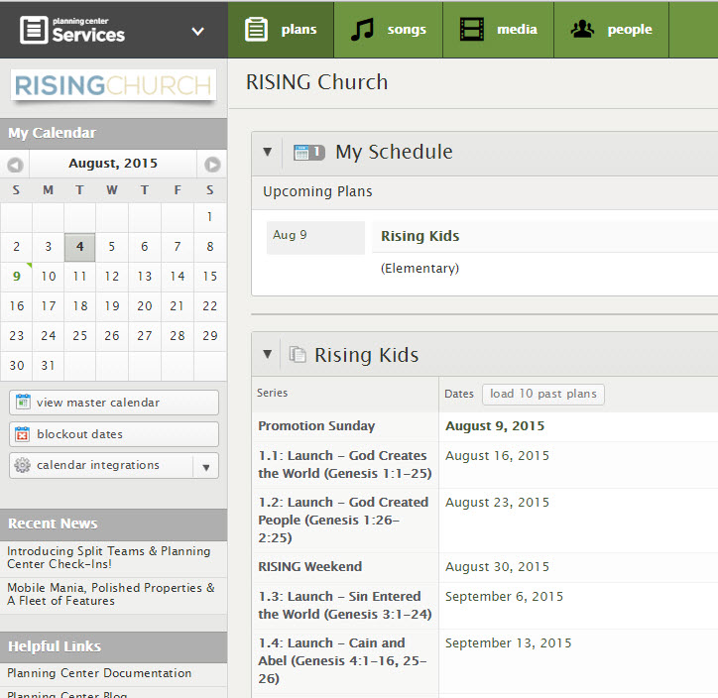

2

1

3

3

2

Plan Page:
By clicking on any of the date(s) shown on your schedule page, you can view the “Plan Page” for any date. The plan page allows you to view the entire service, see who else is serving, and access lesson files.
Anatomy of the Plan Page:
- Service Teams – List of who has confirmed, declined, or has not yet responded to the scheduling request. (This area may be blank if no one has been scheduled yet)
- Ministry Plans – Ministry-specific information for each age group
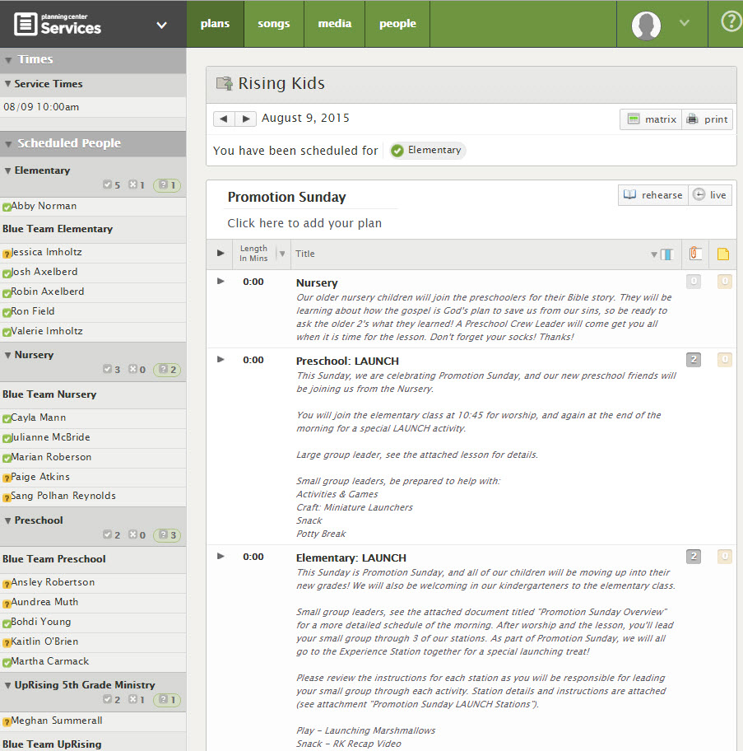
- Hover over these numbers to download and access the pdf documents that have your lesson plans.
2

(Names covered to protect volunteer confidentiality.)

(Names covered to protect volunteer confidentiality.)
1

(Names covered to protect volunteer confidentiality.)
3

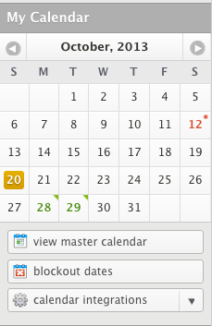
Calendar:
Your calendar is located on the left side of your screen.
- Red dates: These are days that you have blocked out or declined.
- Yellow dates: You have been scheduled for this date but have not yet responded; the service request is still pending.
- Green dates: You have been scheduled and have accepted.
Note: Dates will only appear here if the notifications for those plans have been sent out.

Set Up Text Messaging Notifications

- Click your name in the upper right. Click “Profile”.
- Enter a mobile number in your profile contact information, check the "Enable Text Messaging" box, and then select your carrier and texting options.
- You must choose "Mobile" in the first box to enable Text Messaging.
- Only users with Scheduler permissions or higher will see the "Scheduling Replies" checkbox.
- In order for text messaging to be a free service, Planning Center uses the SMS Gateway provided by each cell company, which is why you must set the cell carrier correctly for texting to work.
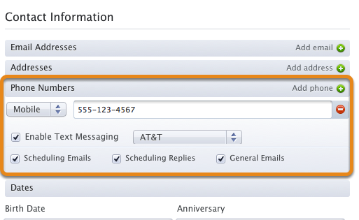

How to Block Out Dates You Are Unavailable

If you are going on vacation or have a business trip planned, you can block out dates ahead of time on Planning Center to let us know well in advance that you won’t be able to serve. You will still be responsible for finding a sub.
1) Click your name in the upper right.
2) Click “Profile.”

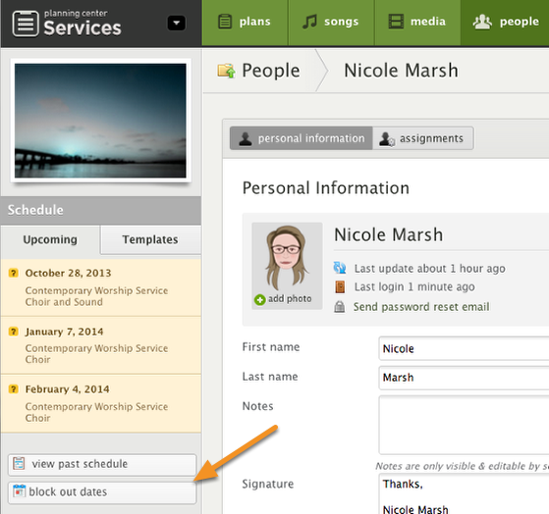

3) To add a block out date, click the “block out dates” button in the “Schedule” section on the left side of your screen.

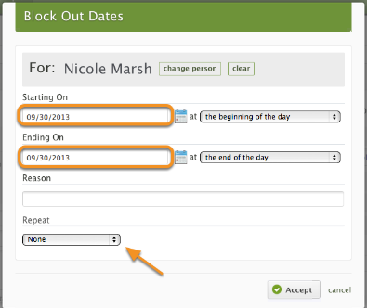
4) Indicate dates to block out by typing in your “Starting On” date and time and “Ending On” date and time. If you prefer, add a reason in the space provided.

5) If you would like this date to repeat, you can choose from the selected options.

6) When finished, click Accept.

How to Confirm or Decline your Availability

Responding to Scheduling Emails
- When you receive your email, click Accept, Decline, or View This Service.
- By clicking “View This Service,” you will be able to access the lessons and other information about the morning.
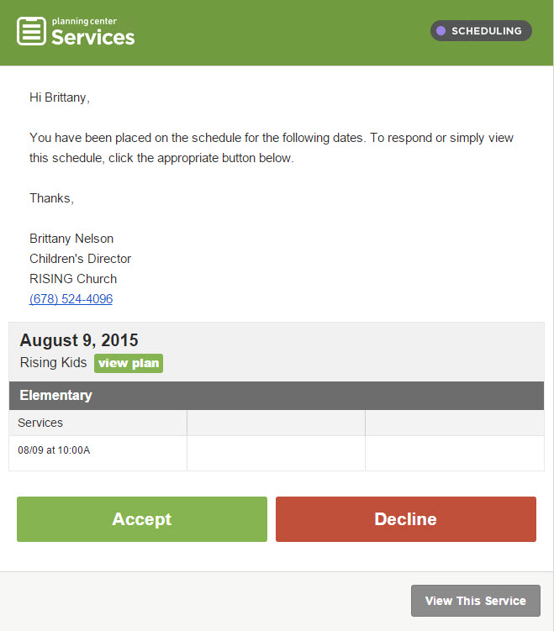
- If you are declining the requested service date, it will give you the option to send a reason. If you do not want to give a reason, you still have to click 'decline and send reason' or 'OK' in order for this response to go through.

Anatomy of the Scheduling Email:
1
- The message portion contains a greeting and other specific details you need to know for the morning.
- The banner through the middle of your email tells you the date and the name of the service you are scheduled for. It includes the ministry area and the time.
- Response Buttons: these large buttons prompt you to respond in some way. Just click the appropriate button to respond.
2
- This button gives you a link to view this plan without responding.
3

4

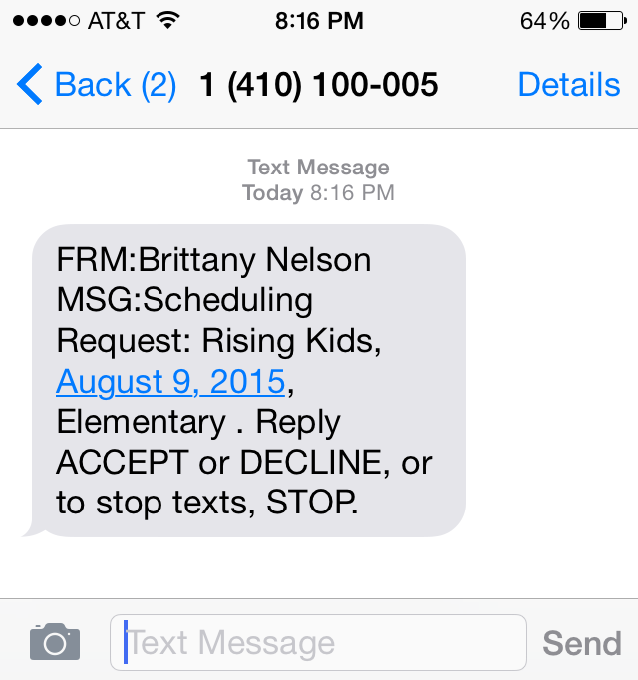
Responding to a Scheduling Request via Text Message
To confirm your availability, type and send “ACCEPT”. To decline your availability, type and send “DECLINE”.

Anatomy of a PCO Text Message:
- Name of the requestor
- "Type" of email that this message is for
- Subject title
- Date of the plan
- Position and People Category

Finding a Sub Option 1

If you are declining the requested service date whether via email or text, you must find your own sub. There are 3 different ways you can find a substitute to serve in your place.

Option 1: Choose someone from our Sub List
- Click the green “People” tab on the top of your screen.
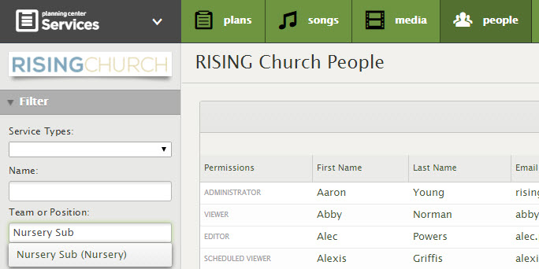
- In the Team or Position box on the left, type your ministry area (Nursery, Preschool, or Elementary) and the word “Sub”. Click on the Sub team from your ministry area (Nursery Sub, Preschool Sub, or Elementary Sub). Hit Enter to apply this filter.
(Names covered to protect volunteer confidentiality.)

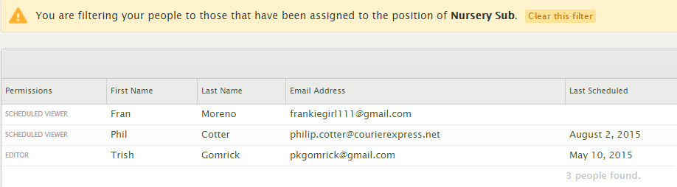
- You will get a list of people who have volunteered to be on our sub list. Look at each sub’s “last scheduled” description to see when the sub last served, and choose the sub who hasn’t been scheduled recently.

(Names and Emails covered to protect volunteer confidentiality.)

- To contact a sub via email, simply click on their email from the screen shown above, copy Brittany/Sara onto the email by adding their names on the left, write your email, and hit send! To contact a sub via phone call or text, click on the sub’s name to access their full contact information. Please notify Brittany/Sara about your sub communication so we can make the proper adjustments in schedules.

- If you have a specific sub in mind, use the Name Box on the People tab to search for a specific person and find their contact information.

Finding a Sub Option 2

If you are declining the requested service date whether via email or text, you must find your own sub. There are 3 different ways you can find a substitute to serve in your place.

Option 2: Choose someone who missed their regular Sunday
- Click the green “People” tab on the top of your screen.

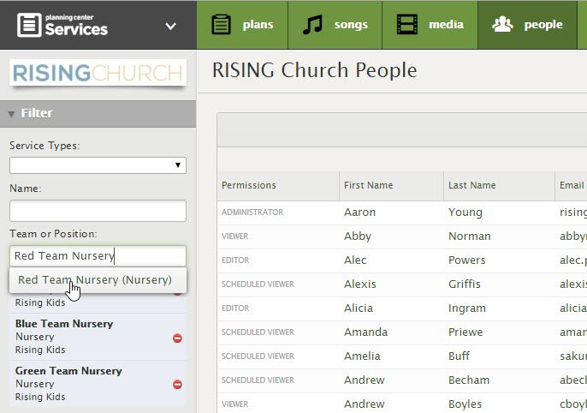
- In the Team or Position box on the left, type another team name in your ministry area. For example, if you are on the Yellow Team Nursery, type in and select the Green Team Nursery, Blue Team Nursery, and/or Red Team Nursery. Hit Enter to apply these filters.

(Names covered to protect volunteer confidentiality.)

- You will get a list of the nursery volunteers on other teams. Look at each volunteer’s “last scheduled” description to see when they last served, and choose a volunteer who hasn’t served in the last month.
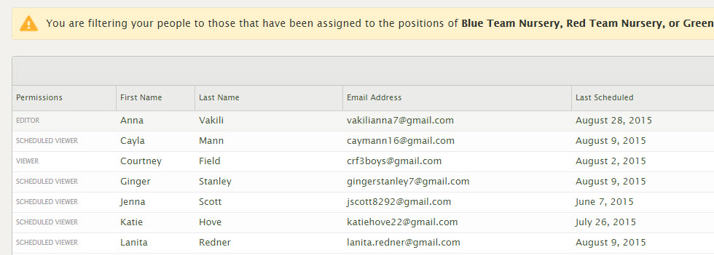

(Names and Emails covered to protect volunteer confidentiality.)

- To contact a sub via email, simply click on their email from the screen shown above, copy Brittany/Sara onto the email by adding their names on the left, write your email, and hit send! To contact a sub via phone call or text, click on the sub’s name to access their full contact information. Please notify Brittany/Sara about your sub communication so we can make the proper adjustments in schedules.

Finding a Sub Option 3

If you are declining the requested service date whether via email or text, you must find your own sub. There are 3 different ways you can find a substitute to serve in your place.

Option 3: Switch weeks with another volunteer.
- Follow Steps 1 and 2 from the Finding a Sub Option 2 Page.
- OR use this handbook to look up the name(s) of volunteer teams that serve in your ministry area on a different week.
- You can look up a specific volunteer by typing that volunteer’s name in the Name Box on the People tab to find their information.
- Select a volunteer who has not yet served during the current month.
  - It is best to choose someone who has not yet served that month so that they can serve in your place and you can serve in theirs later in the month.
  - If you choose to switch with someone who has already served for the month, you may serve twice in the next month (on their regular week and yours) since they would serve twice in one month in your place.
- Email them about switching weeks and include Brittany/Sara in on your plans so we can make the appropriate changes in Planning Center.

NOTE: Choosing this option may result in your serving twice in one month or for two weeks in a row depending on who you switch with.

Download the PCO App and do it all from your phone!

Don’t spend much time on your computer? Search “Planning Center Online” in the Google Play Store or the Apple Store, download the free app, sign in using your username and password, and you’re all set! You can now access your calendar, confirm or decline requests, and download lesson plans from your phone or mobile device.

Safety & Discipline
The 5 “I Cans” of RISING Kids

Our “I Can” Statements allow our kids to take ownership of their time at RISING Kids each week and empower them to CHOOSE to do the right thing. Rather than describe all that the kids CAN’T do, these statements describe everything the kids CAN do and they clearly set out the behavior expectations we have at RISING Kids. The acronym to help us remember our 5 I Cans is SLLRP (pronounced “slurp”). Learn more about SLLRP here and learn more about an introductory SLLRP lesson here.
I Can Stay Safe – This statement covers everything from “keep your hands to yourself” to “don’t climb on that table” and allows kids to take responsibility for their choices and actions.
I Can Listen – With our “I Can Listen” statement, kids know they are expected to listen to whomever is speaking, whether it is a leader up front or a friend in small group.
I Can Learn – We want kids to know that RISING Kids is a place where they can learn more about Jesus, His story in the Bible, and how it applies to their lives today. This “I Can” Statement goes closely with listening and reminds kids that they will see, hear, experience, and sometimes even smell new things. Knowing this expectation of learning from the beginning helps kids prepare their hearts and minds for what God has to teach them each week.
I Can Respect – We all know kids need reminders about what respect looks like. Respect is not talking when the teacher is talking. Respect is not talking to your friend during the lesson because then they can’t hear. Respect is not making fun of someone. With our “I Can Respect” statement, kids are given a friendly reminder to be respectful in a positive way.
I Can Participate – Participation looks different based on the different activities we are doing, but it basically means going with the flow and doing whatever we are doing at the time. If we are worshipping, participation looks like standing and singing praises to God. If we are playing a game, participation looks like joining in and supporting your team. If we are having a lesson, participation looks like sitting quietly and listening to what the teacher has to say. The most important aspect of this “I Can” Statement is having FUN! When kids participate, they have more opportunities to have fun. Yes, it is a place of learning, but it is also a place of joy and excitement!

Discipline: 3 strikes and you’re out!

If a child is having trouble maintaining the expectations of SLLRP at any RISING Kids or RISING Church event, use the following “3 strikes and you’re out” procedure. No physical discipline is allowed.
- 1st offense – 1 to 2 verbal warnings; remind children of our 5 I Cans
- 2nd offense – If they keep being disobedient, they will have to sit out of an activity (at this point let the director know this action had to be taken)
- 3rd offense – Send the child to the director where they may be sent home or will sit out of the rest of the morning; they will also fill out an Incident/Accident Form describing their offense, why it was wrong, and how they can make better decisions next time.

Incident/Accident Forms

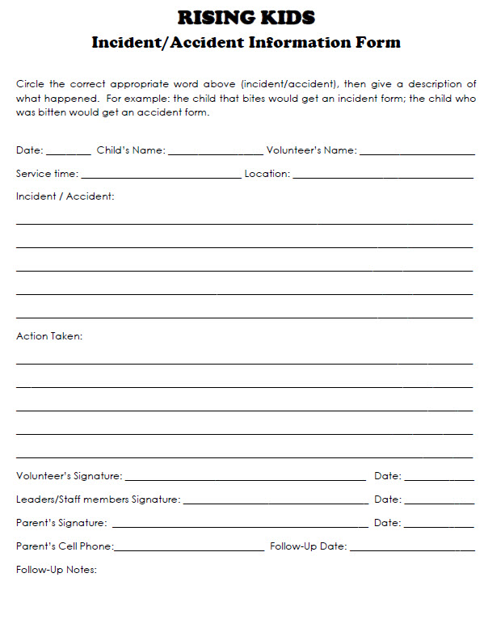
If a serious injury, physical altercation, or other disciplinary issue occurs, an Incident/Accident Form will be filled out by the witness volunteer and a RISING Kids Staff Member, and the parent will be notified and followed-up with. Follow the directions on the form for specific instructions and be sure to complete the form in its entirety. These forms are located in supply bins in each classroom and should be turned in to a RK staff member.
Medical Release/New Kid Information
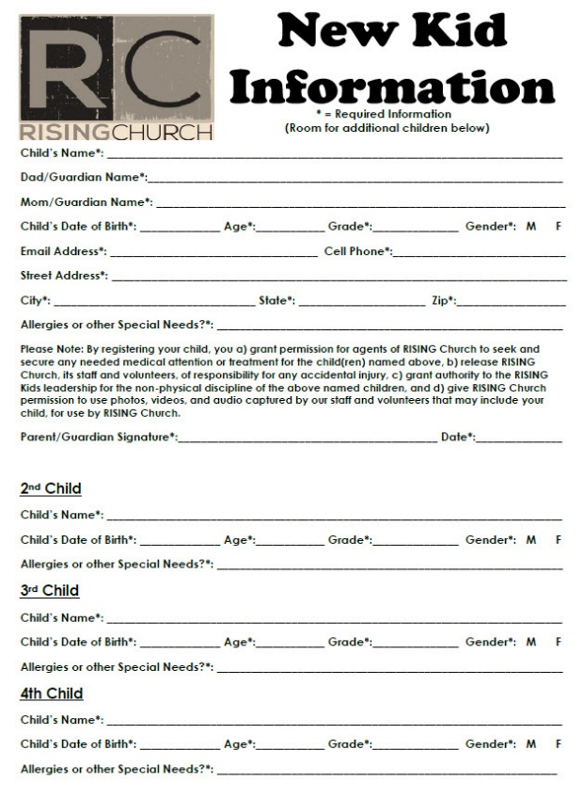
(Find free copies of the Med Forms here.) All parents who leave a child in the care of a RISING Kids ministry MUST have a RISING Kids Medical and Media Release Form or New Kid Information Form on file with the RISING Kids office. All new/visiting families leaving their children with RISING Kids must complete a New Kid Information Form before leaving their child in our care. These forms are located at all check-in locations and should be turned into a RK staff member.

Confidentiality
All information about the children in our program and their families shall remain confidential unless it is determined that harm may come to the child and in that event, the Director of Children’s Ministry should be notified immediately and actions will be taken in line with the RISING Church procedures.

Further details on the safety and protection of our children can be found in the Safety Policy Manual continued in the rest of this book.
RISING Church
SAFETY POLICIES AND PROCEDURES

“FOR THE PROTECTION OF THE VOLUNTEERS, CHILDREN & YOUTH AT RISING CHURCH”

Why do we need a Safety Policy?
- We want to provide our children and youth in our care a safe and secure environment.
- We have a biblical command to keep our children and youth safe. (Matthew 18:5-6)
- It is a Rising Church Core Value: “We will be people of integrity. Conducting ourselves with integrity will glorify God and provide nourishment for our ministry. (Proverbs 10:9, Proverbs 15:3)”
- We need to protect volunteers against false allegations of abuse.

Church Policy Statement of Covenant
- Rising Church will screen all paid and volunteer workers
- Rising Church will establish operating procedures
- Rising Church will train all workers (see training details below)
- Rising Church will have a reporting system (see reporting details below)

Volunteer Requirements
- Consent to run background check
- Complete background check authorization
- Pass the background check with no red flags
- Attend Training on church policy and procedures
- Join Rising Church as an active member

Church Staff Responsibilities
- Provide background check authorization form to all volunteers
- Make sure resulting information is kept confidential
- Conduct training, instructing volunteers on policy and procedures
- Spot check / supervise volunteers to see procedures are being followed
- Review policy and procedures annually at the beginning of each school year with all past and current volunteers
- Collect and maintain updated medical and media release forms for students and children on an annual basis

Background Check Overview
- All Staff and Volunteers will be required to submit to a periodic background with a frequency as required by Rising Church Elders.
- Any individual with a molestation inquiry or charge will be deemed unable to volunteer with Children or Youth at Rising Church.
- Any individual with an alcohol or drug related charges on their criminal history check in the previous 3 years will be deemed unable to volunteer
- Any Individual with more than three incidents on their Motor Vehicle Report in previous 3 years will not be allowed to drive children and students
- Any individual with an alcohol or drug related Motor Vehicle Report violations in the previous 3 years will be deemed unable to drive our children / students

Staff and Volunteer Training Components
  - Child Abuse – It does happen.
    - 1 in 16 children suffer from sexual abuse.
    - Over 25% of abused children are under the age of three while over 45% of abused children are under the age of five.
    - 3 million reports of child abuse are made each year in the U.S.
    - 90% of child sexual abuse victims know the perpetrator in some way. 68% are abused by a family member.
  - Types of Abuse
    - Physical - the use of physical force that may result in bodily injury, physical pain, or impairment
    - Sexual - any sexual act with a child performed by an adult or an older child
    - Emotional - any act including confinement, isolation, verbal assault, humiliation, intimidation, infantilization, or any other treatment which may diminish the sense of a child’s identity, dignity, and self-worth
    - Neglect - a type of maltreatment that refers to the failure by the caregiver to provide needed, age-appropriate care although financially able to do so or offered financial or other means to do so
    - Ritual – abuse of children as part of rituals associated with occult or religious practices
- Profile of a Child Molester
- Known by child 80% of the time
- Takes place in ongoing relationship
- Between 20 – 30 years old
- 20% abuse sexually before age 18
- Child abusers are often married with children of their own
  - Reporting System
    - Accidents – when an unintentional act occurs and a child is hurt; a copy of this form is given to parents
    - Incidents – When an action is observed that does not require reporting to DFCS, but does require attention; a copy of this form may or may not go to parents
    - Suspected Abuse – When one sees, has been told of, or suspects child has been abused in some way
    - Fill out the appropriate form above and turn into Director of Children’s Ministry
    - A copy of these forms should be present for all children’s events

- How a Report is made when questionable behavior occurs:
- Accident – Witness gives written report to Staff member, who takes appropriate action, giving the parents a copy of the form
- Incident – Witness writes report. Staff speaks with involved parties, offering training or counseling if appropriate
- Suspected Abuse –
- Report is filed with Department of Family and Children’s Services (DFACS), the agency responsible for investigation alleged incident.
- Police are called if immediate danger is suspected
- Pastor and Elders are informed
- Elders notifies Church Attorney and Insurance Company
- Only pre-designated person speaks with the media
- All information should be kept confidential to protect involved persons
- Pastoral support should be offered to both the victim and the accused
  - Procedures to protect children and those who work with them (see below)
  - Each volunteer will read and sign a statement of agreement with the above information and signed document will be kept on file

General Operating Procedures
- Two Person Rule – no adult may be alone with a child at any time; two adults must accompany a child alone or one adult may accompany two or more children at a time
- Windowed Doors or Open Doors – doors to classrooms and restrooms must remain open at all times; if a door must be closed, there should be windows that allow visibility into the room
- No one under 18 in charge – even if a student is teaching, an adult must be present in each classroom at all times
- Four years older than supervised group – no volunteer may serve an age group less than 4 years their minor
- Volunteers and staff will wear nametags or identifying clothing – volunteers will wear easily-identifiable nametags or lanyards that denote their role as a volunteer with the children’s ministry
- Appropriate touch policies
- Release child to appropriate adult only (or youth over 14 years old) –only a parent or legal guardian may pick up a sibling; youth under 14 will not be allowed to pick up or drop off a child

Ministry Specific Procedures – Off Site Trips (day / overnight)
- If the participants are male and female, then male and female chaperones must be present.
- Males and females attending events should not share the same sleeping quarters and should have separate restroom facilities. In the absence of separate facilities, restrooms shall not be accessed by members of the opposite gender at the same time (i.e., rotate usage).
- Experienced adult workers should be included with adults who are newcomers to ministry when planning overnight activities.
- All contact information shall be provided to and received from parents
- Adequate ratios
  - Nursery – 1 adult: 3 children
  - Preschool/Elementary – 1 adult: 5 children (of same gender)
  - Middle School 1 adult: 7 students
  - High School – 1 adult: 7 students
- Written parent permission
- When possible, at least 1 adult and 2 children in sleeping rooms.
- Overnight – No adult shares a bed with a child
- Church events – at least two adults must remain while children/students are present. A single adult volunteer or staff member waiting with a child/student for a parent to arrive creates a potential compromising situation for volunteer/staff.

Diapering and Restroom Activity
- Diapering
  - Done by the designated Nursery Lead Volunteer
  - Changing table will have a plastic covering and then covered with a square of wax paper.
  - Nursery Lead Volunteer will always wear gloves and gather supplies before placing child on table.
  - At no time is a child left on a table without an adult standing at the table.
  - Diaper will be changed, baby’s area cleaned with a wipe and powder or lotion applied only if parents provided for it.
  - Old diaper will be folded and covered with a glove and discarded into a diaper pail kept in the changing room. Other glove will be discarded at this time.
  - A fresh diaper will be applied and the child will be redressed.
  - Wax paper will be removed and replaced with new wax paper for next child
  - Another adult (age 18 or older) present
  - Done in a visible area
- Toddler and Preschoolers
  - Adult supervises, but allows child independence
  - Potty “accidents” requiring helping with two adults witnessing
  - Open door/open stall
  - 2 adults at all times
  - Ensure proper handwashing
  - Inform parent

Restroom visits with “bigger kids” (Elementary)
- Do not allow child to go to restroom alone. TAKE at least 2.
- Tell other adult (Leave classroom door open!)
- Do not assist child unless there is an emergency
- A group of 3 at all times (2 children & 1 adult or 2 adults & 1 child)
- Inform parents of accidents/assistance

Discipline Basics:
- Use positive words
- Establish rules and expectations
- Tell parents the good, the bad, the good (Sandwich Rule)
- Involve church staff when necessary
- 3 strikes and you’re out policy
  - 1st offense – 1 to 2 verbal warnings
  - 2nd offense – If they keep being disobedient, they will have to sit out of an activity (at this point let the director know this action had to be taken)
  - 3rd offense – Send the child to the director where they may be sent home or will sit out of the rest of the morning; they will also fill out an accident/incident form describing their offense, why it was wrong, and how they can make better decisions next time.

Why is all this necessary?
- We MUST protect our children and youth from a lifetime of pain and injury causing loss of spirit, trust and faith.
- We MUST make sure our staff, volunteers and elders are supported in case of frivolous lawsuit.
- We MUST prevent loss of millions of dollars in legal fees and damages to victims.
- We MUST not cause one child or one adult to become a victim!

Acknowledgment

I, (Print Name) ______________________________________________________, sign and affirm I read the above Policy for Protection of Children at Rising Church in its entirety, and that I will faithfully follow and abide by all policies, procedures and guidelines pertaining to ministry leadership of children, youth and/or special needs individuals and the ministry role I am assigned.

Signed

_
First name / Last name Date

